­

**ZOMATO RESTAURANT ANALYSIS**

Analyze the data and come up with strategies to open new restaurant

OBJECTIVE:

Objective Questions:

Note: Each objective question is answered in the format of answer and approach if needed

**Q1.** What is the total no. of tables present in the data?

**Ans:** There are two tables in the given excel workbook one is the table in excel sheet raw data which contains the details of restaurants, another one is in excel sheet country description which contains a table which has details regarding country and their country code.

**Q2.** What is the total no. of attributes present in the data?

**Ans**: There are 20 columns in table which is in Raw data sheet and 2 columns in table which is in country description sheet.

**Approach:** I have used excel formula =COUNTA and selected the range of header cells of the table to get the number.

**Q3.** How many categorical columns are there in the data?

**Ans.** There are 11 categorical columns in the table which is in the raw data.

**Approach:** I counted categorical columns manually.

**Q4.** The data consists of some inconsistent and missing values so ensure that the data used for further analysis is cleaned.

**Ans.** We used find and replace function to fill the blank cells in the raw data sheet.

**Approach:** There are 9 blank cells in cuisines column, I don’t want to make direct modifications to the given raw data so I made a new column cusines_updated and filled the blank cells with a normal default value “Spicy Food”, The format of the DateKey_Opening is not in correct date Time format so I have created a new column DateKey_Opening_updated and converted the values to date time format.

**Q5.** Using the Lookup functions, fill up the countries in the original data using the country code.

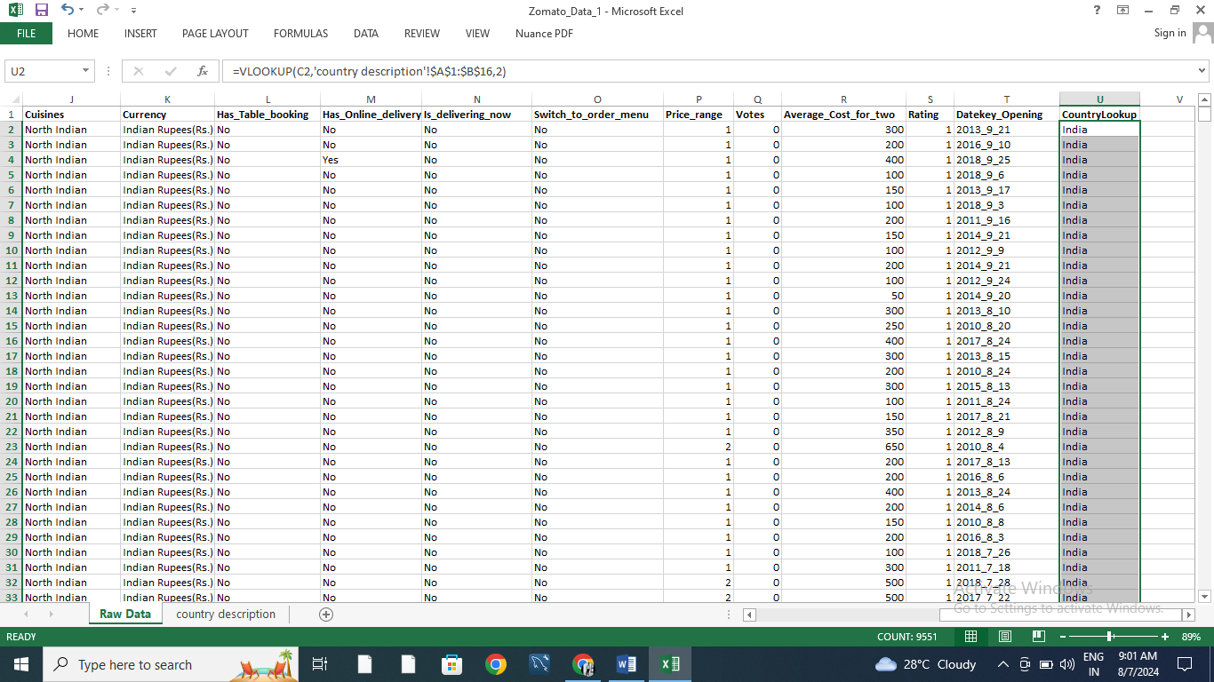**Approach:** I have created a new column with name CountryLookup to CountryCode and used a VLOOKUP Function**(=VLOOKUP(C2,'country description'!$A$1:$B$16,2) )**. I got the value for country and using fill handle filled column.

**Q6.** Create a table to represent the number of restaurants opened in each country.

**Approach:** We have created a new sheet named pivot table and then added a pivot table to it. We have given the whole raw data as its range and added the Country column as its rows and selected Count of Restaurants ID as its values.

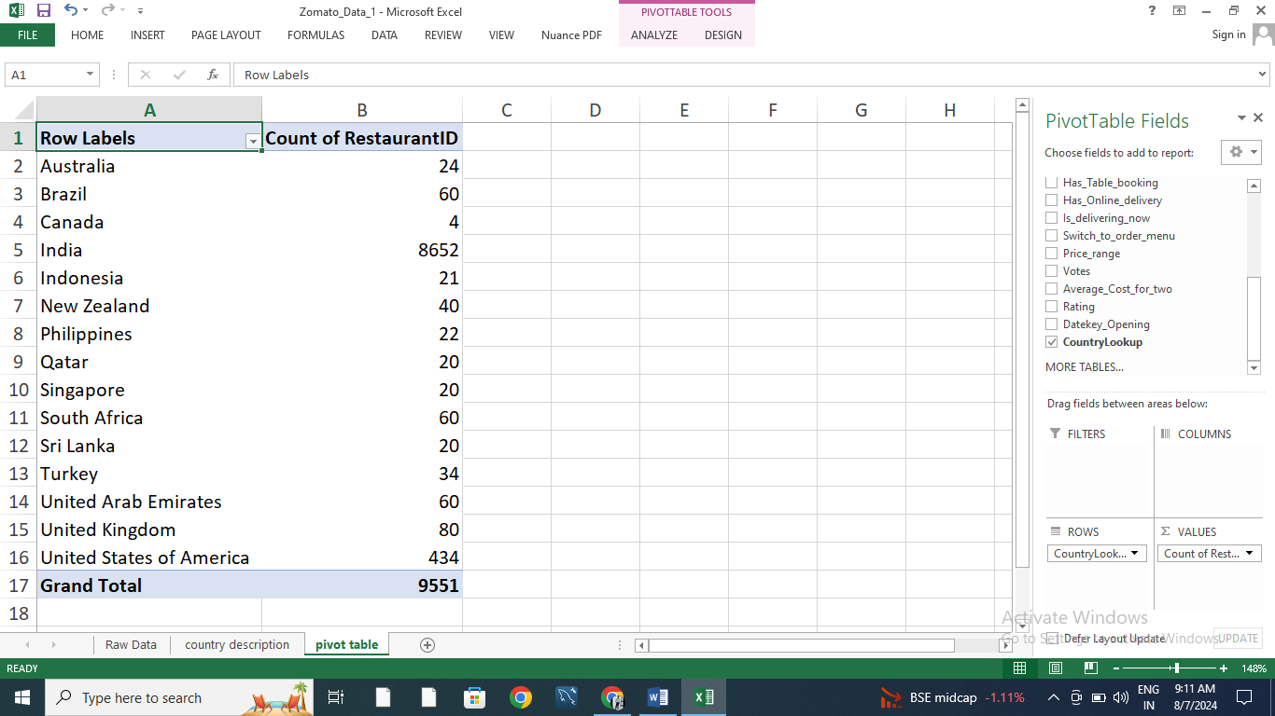

.

**Q7.** Also, the management wants to look at the number of restaurants opened each year, so provide them with something here.

**Approach:** We have created a new column which contain left four chars of our datekey_opening which is year and We have created a pivot table in our pivot table sheet We have given the new column DateKey_Opening_year as rows and count of restaurant id as values.

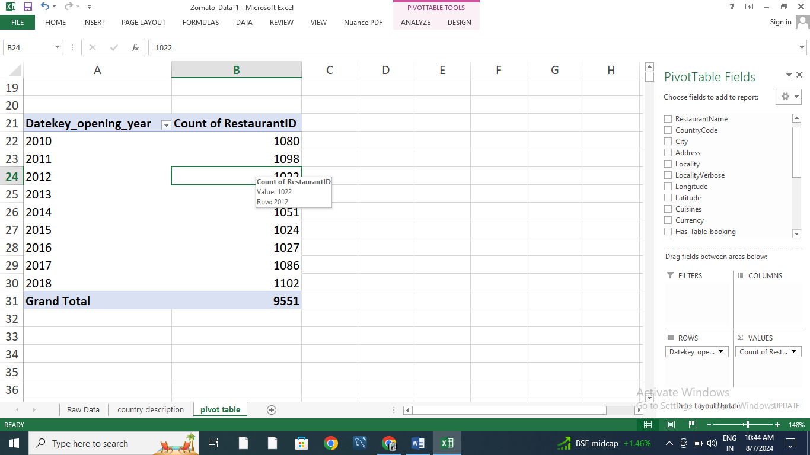

**Q8.** What is the total number of restaurants in India in the price range of 4?

**Approach:** I have created a new Pivot table with price_range as rows and count of RestaurantID as values and added a slicer for Country and filtered the data for India, from this table we can see that there are **388 restaurants** in India in price range of 4.

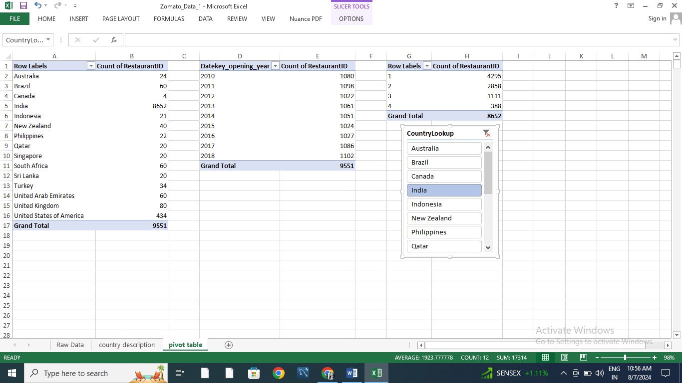

**Q9.** What is the average number of voters for the restaurants in each country according to the data?

**Approach:** We have created a new pivot table with country as rows and average no. of votes as values to get the required data.

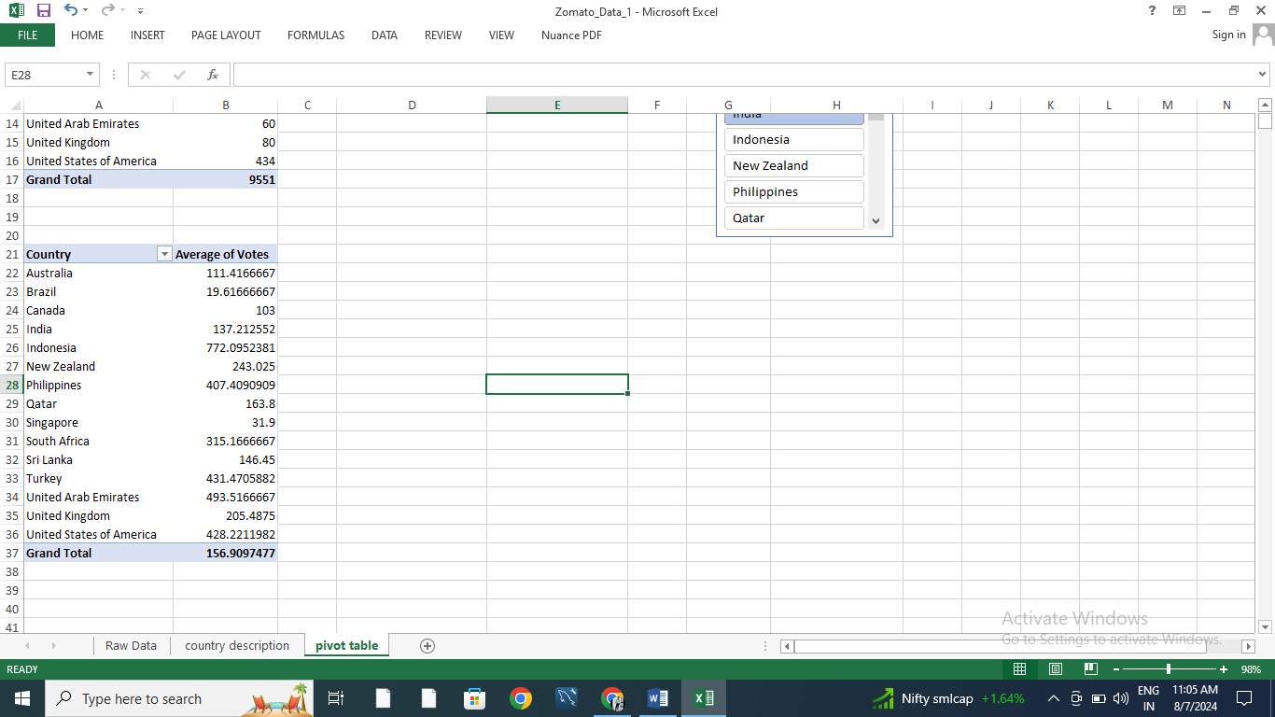

**Q10.** Calculate the average rating for all the restaurants that have price_range < 4 and provide online delivery. Use only the “IF” function, Logical Operators, and Aggregation functions to solve this problem.

**Approach:** I got average rating as **3.27381151**, I have used the formula: “**=AVERAGE(IF(('Raw Data'!R2:R9552<4)*('Raw Data'!O2:O9552="Yes"),'Raw Data'!U2:U9552))”**to the average rating.

**Q11.** Using Conditional formatting highlight the rows of restaurants that are located in the countries or cities that you’ve suggested to the management for opening new restaurants.

**Approach:** I have analyzed the data and taken insight from the pivot table sheet where I found countries like **UNITED ARAB EMIRATES, UNITED KINGDOM, SINGAPORE AND QATAR** are having least no. of restaurants and their currency exchange value is also decent which was analyzed by currency exchange sheet.

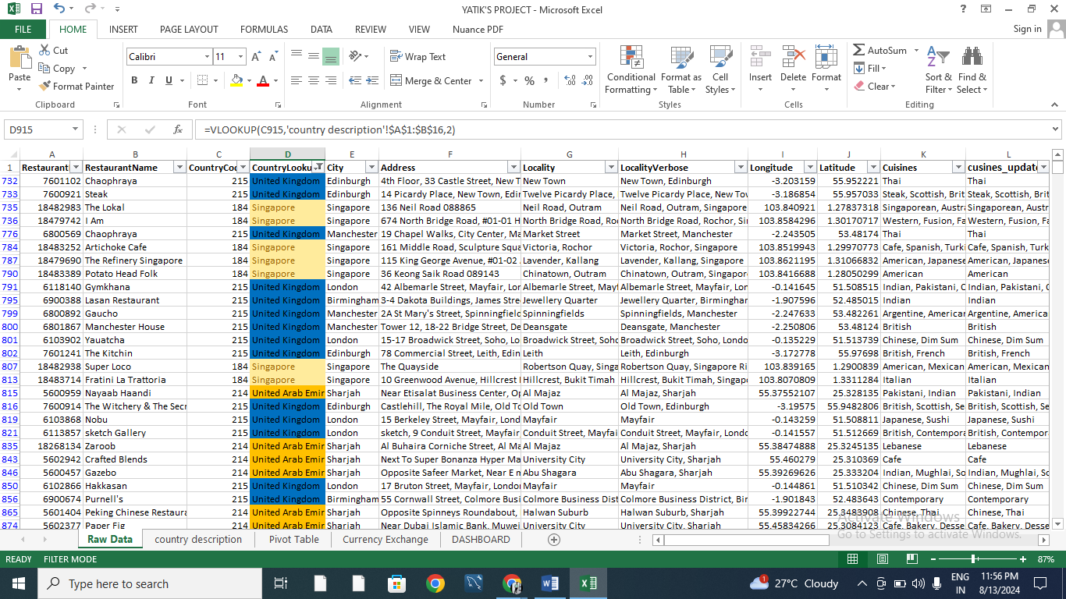

**Q12.** Create a new customized price column that consists of the abbreviation/symbol of the currency along with the Average_cost_for_two value.

**Approach:** We use TRIM function along with MID and FIND function in the new column created named as customized price.

**Formula:** **=TRIM(MID(M2, FIND("(", M2) + 1, FIND(")", M2) - FIND("(", M2) - 1)) & T2**

**Q13.** How can you create an array formula in Excel or Google Sheets to count the number of restaurants listed that do not offer online delivery, are in the lowest price range, and have an average cost for two people less than or equal to 250 Indian Rupees?

**APPROACH:** After using the array formula with a combination of SUM and IF conditions we got **1685** numbers of restaurants which has average cost for 2 people less than or equal to Rs.250 and didn’t offers online delivery and has lowest price range.

**FORMULA: (*Here we use array formula) :-*=SUM(IF((O2:O9552="NO")*(R2:R9552=MIN(R2:R9552))*(Y2:Y9552<=250),1,0))**

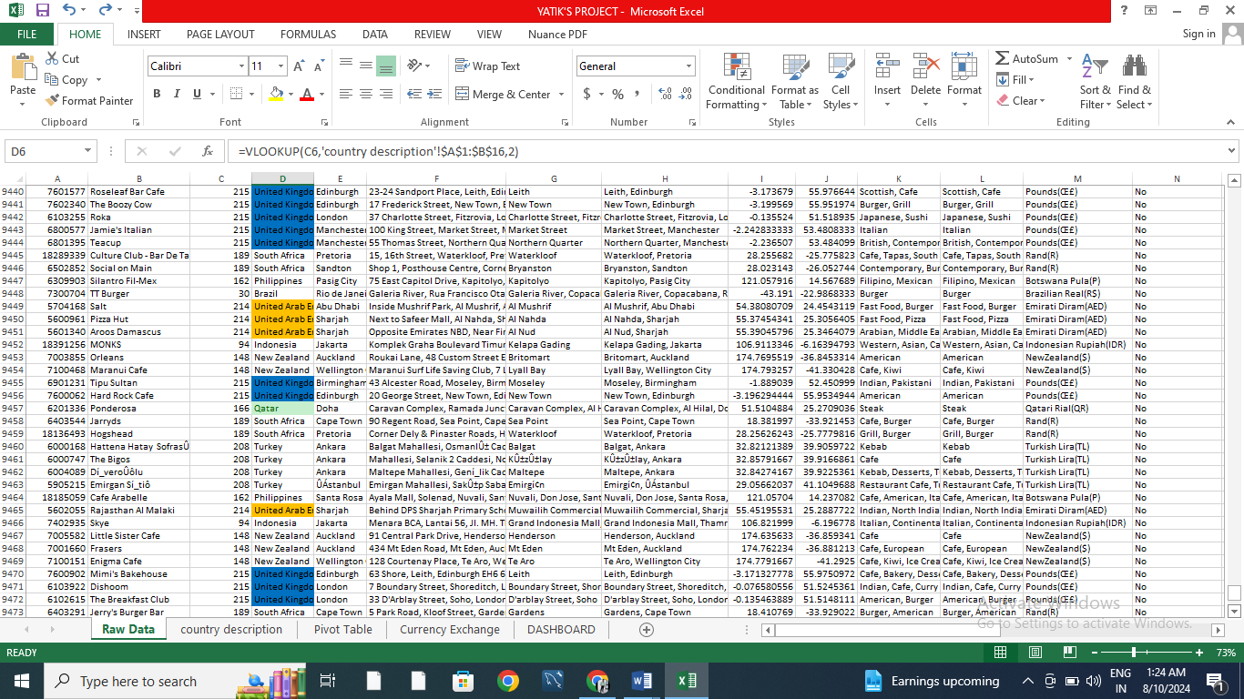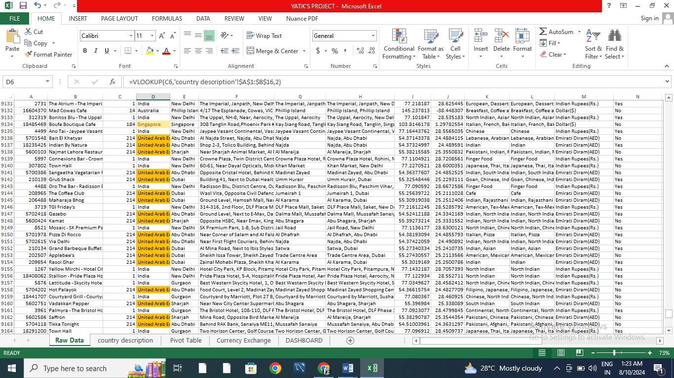

Subjective Questions:

**Q1.** Suggest a few countries where the team can open newer restaurants with lesser competition. Which visualization/technique will you use here to justify the suggestions?

**ANS. Suggestion-** In my opinion we can open several luxurious restaurants in countries like –

1. United Arab Emirates
2. Qatar
3. Singapore
4. United Kingdom

**Insight :**

● **Qatar** have 20 restaurants with an average rating of 4.06, This suggests that while there is some competition, the market is not saturated, leaving room for new entries.

● **United kingdom**  have 80 restaurants with an average rating of 4.01, reflecting a balance between online and table bookings and relatively high customer satisfaction.

● **United Arab Emirates** have only 60 restaurants. These numbers are significantly lower than in other countries, such as India, where there are over 8,600 restaurants.

● **Singapore** have 20 restaurants, reflecting a balance between online and table bookings and relatively high customer satisfaction.

**Recommendation:**

* Because there are fewer luxurious restaurants in these countries, people are coming to these for vacations and to spend money on good quality food and hotels, we can open restaurant there.
* Rating of restaurants is good in the suggested countries.
* All this countries have varieties of cuisines in 1 to 4 Price range.
* The number of restaurants providing online delivery is very low.

Here is the chart for the countries which have less no. of luxurious restaurants.

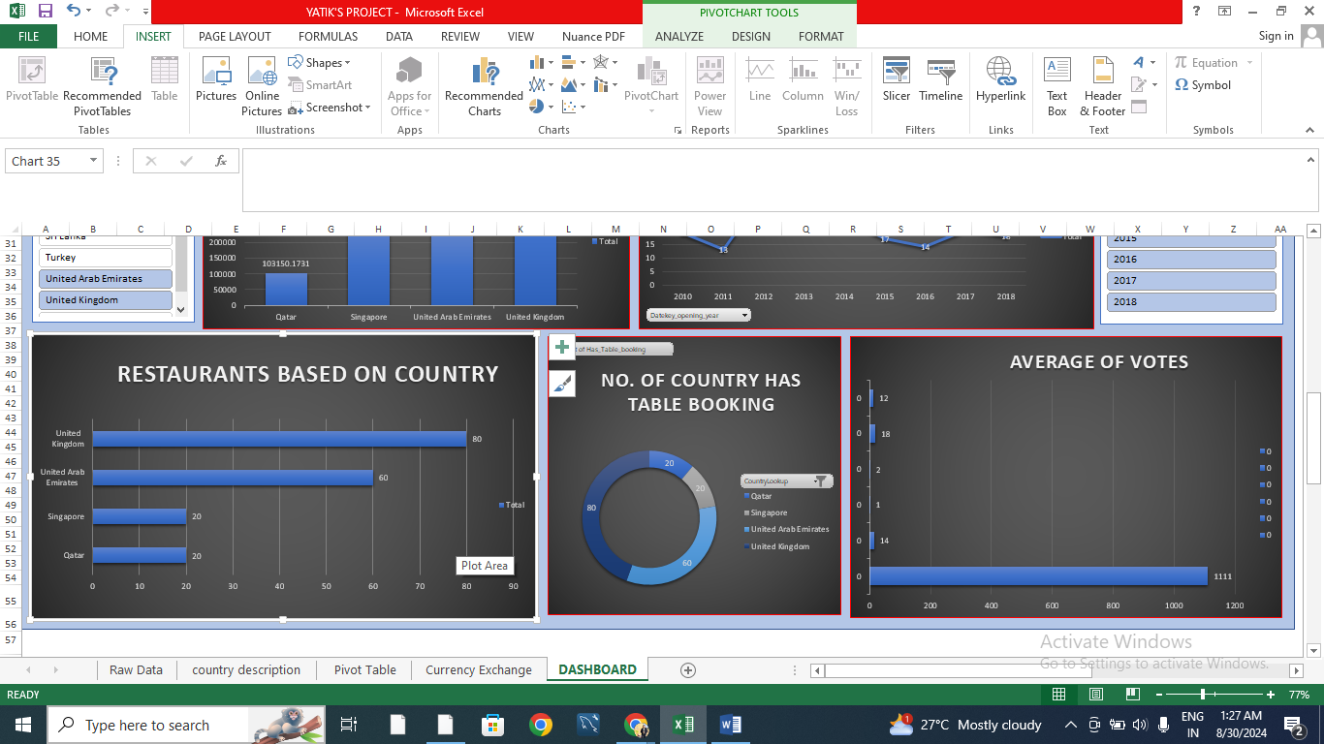

**Q2.** Come up with the names of States and cities in the suggested countries suitable for opening restaurants.

**ANS. Suggestion-** In the suggested countries we can open restaurants in these cities-

1. Birmingham
2. Doha
3. Dubai
4. Edinburgh
5. London
6. Manchester
7. Sharjah
8. Singapore

**Recommendation:**

* We can open new restaurants in the suggested countries as it has less no. of restaurants.
* Their rating is good enough.
* All this countries have varieties of cuisines in 1 to 4 Price range.
* The number of restaurants providing online delivery is very low.

**Insights:**

● **Birmingham** have only 1 restaurant. This suggests that competition is low that there is opportunity for new restaurants.

● **Edinburgh** has only one restaurant, making it an ideal location with minimal competition. The average rating of 3 suggests room for improvement, offering an opportunity to introduce new dining experiences.

● **Doha** While Singapore has 20 restaurants, the consistent average rating of 4.06 this is higher than the average of the market.

● **London** has 1 restaurant, the consistent average rating of 3.4 indicates steady demand. This presents an opportunity for new entrants to differentiate themselves with unique offerings.

● **Sharjah** has only one restaurant with a low moderate rating of 3.3, This creates an opportunity for a new restaurant to capture the market by offering a superior dining experience.

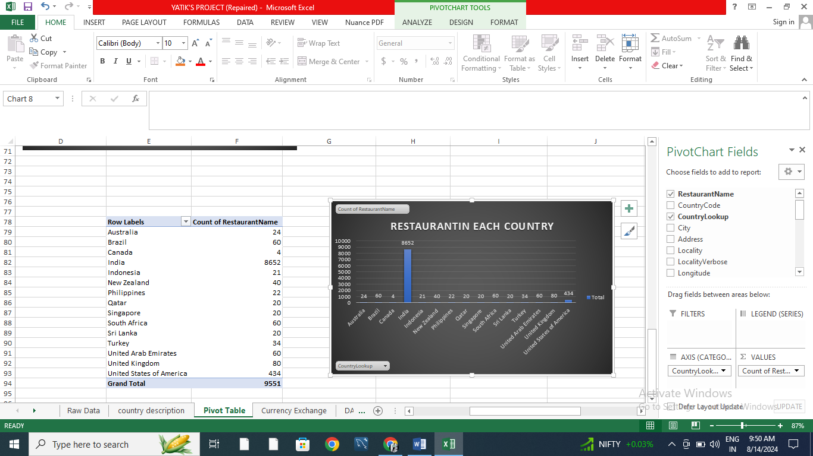

**Q3.** According to the countries you suggested, what is the current quality regarding ratings for restaurants that are open there?

**ANS. Suggestion-** In the suggested countries for opening the newer luxurious restaurant if we look at the rating of the restaurants that opened in the past is very good all countries' restaurants have ratings of 4.0 and above except Singapore. But we can manage it because it is the most visited tourist country and Singapore's infrastructure is very famous for its restaurants and beaches and ports.

1. Qatar
2. Singapore
3. United Arab Emirates
4. United Kingdom

**APPROACH:** With filter database suggested country, Focus on QATAR, SINGAPORE, UNITED ARAB EMIRATES and UNITED KINGDOM. We calculated average rating through pivot table and its chart respectively.

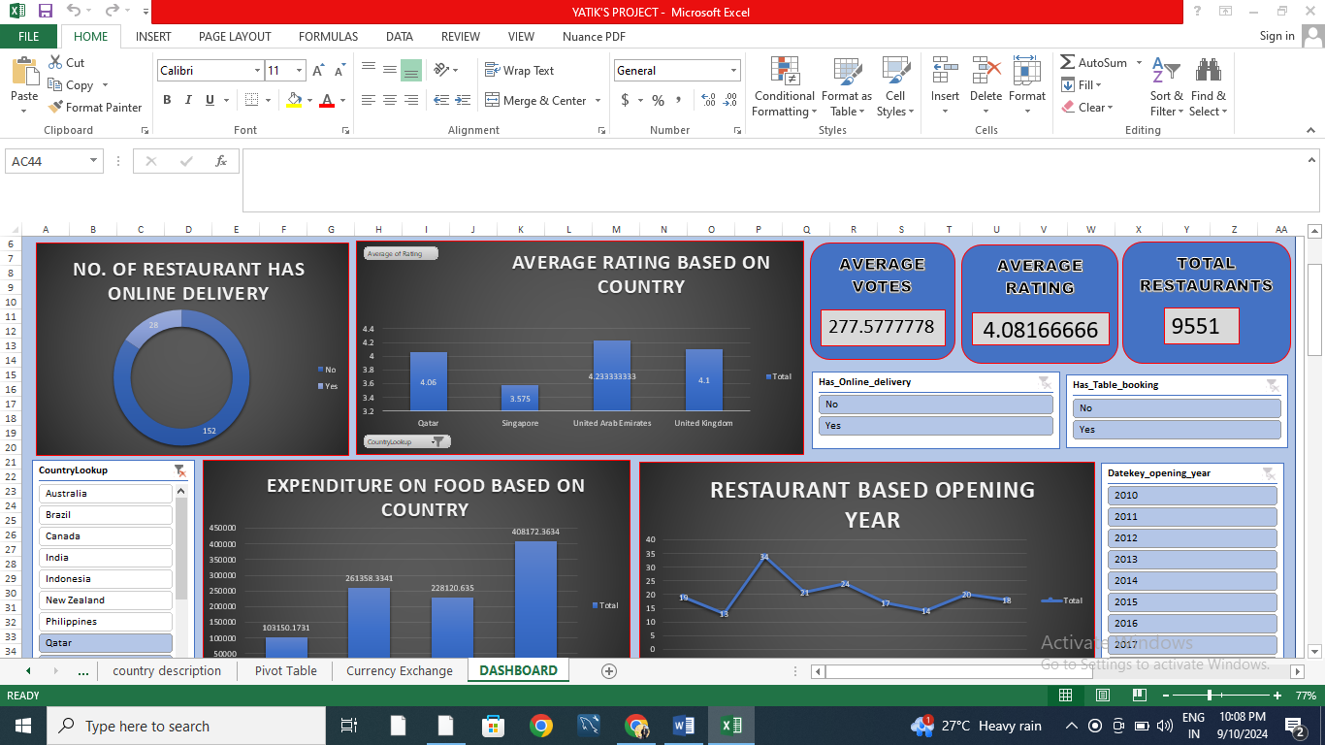

**Q4.** What is the current expenditure on food in the suggested countries, so we can keep our financial expenditure in control?

**ANS.** If we look at the current expenditure on luxury foods and their cost in INR in the suggested country, QATAR, SINGAPORE, UNITED ARAB EMIRATES and UNITED KINGDOM.

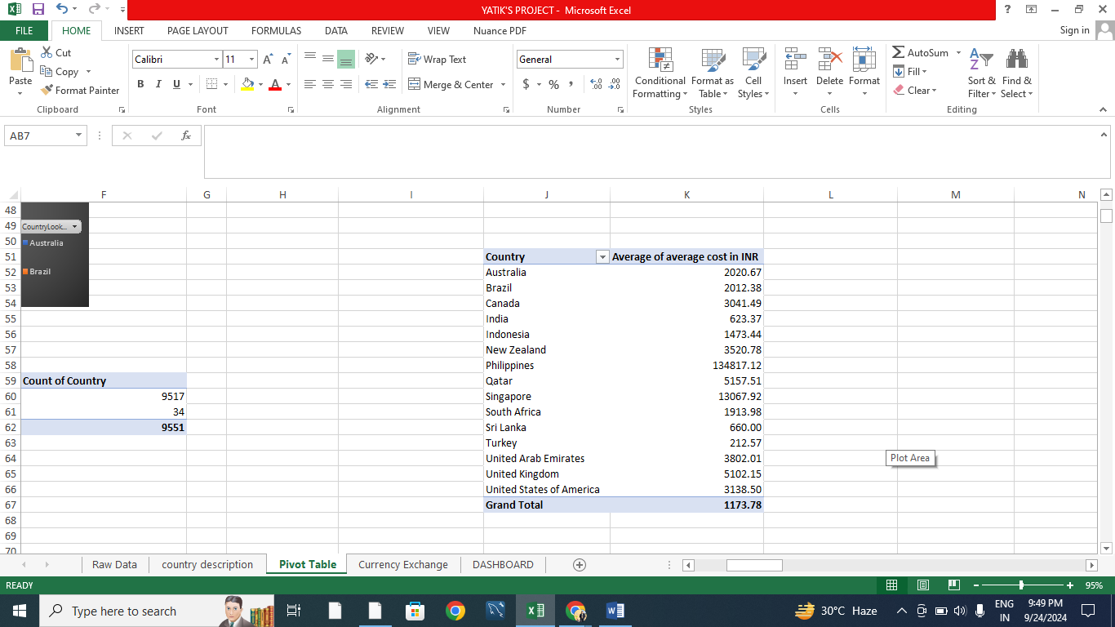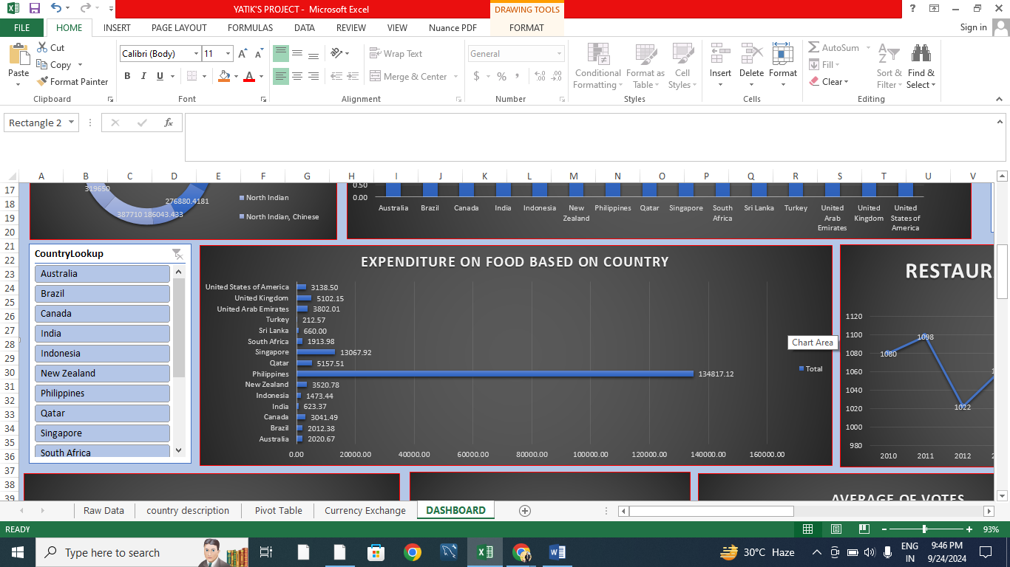

**APPROACH:** With filter database suggested country, Focus on QATAR, SINGAPORE, UNITED ARAB EMIRATES and UNITED KINGDOM. We convert the currency in INR and then we calculated Expenditure on food through pivot table and its chart respectively.

**Q5.** Come up with the names of restaurants from the recommended states that are our biggest competitors and also those that are rated in the lower brackets, i.e. 1-2 or 2-3.

**ANS. Approach:** There is no restaurant in my suggested which has ratings in the lower brackets of 1-2 and 2-3.

**Insights:**

In the below data of these restaurants name for good competitor in the market.

**Recommendation:**

Tresind – Nassima Royal Hotel has the highest rating above 4. There is no single restaurant which has the lowest rated restaurants among the suggested countries. Focus on providing a quality and unique experience will definitely help capture a larger market and improve the average cost.

There are many restaurant which is our biggest competitor in the price range (4). Name are as follows –

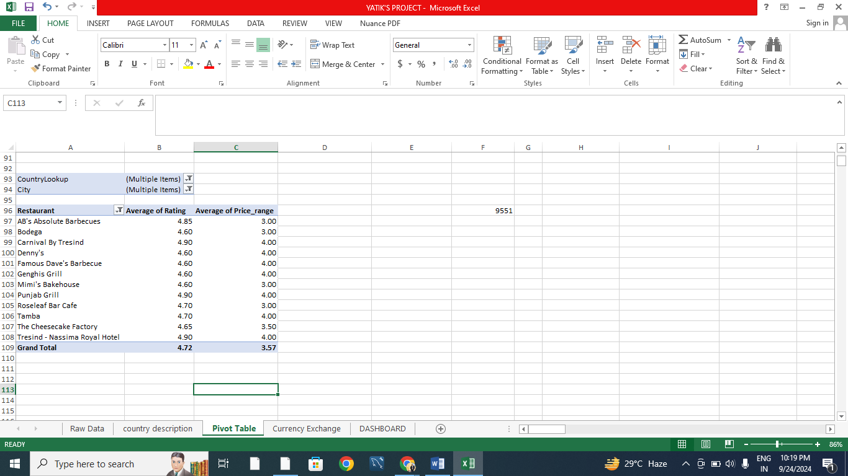

**Q6.** Which cuisines should we focus on in the newer restaurants to get better feedback? Does the choice of cuisines affect the restaurant ratings?

**Approach:** Cuisines with good ratings i.e. those cuisines which are already performing well in the countries can be introduced in new restaurants branches to generate good amount of revenue at the start. After that we can introduce the local cuisines also according to the future demands by customers.

**Insights:**

1. Restaurant in Abu Dhabi and Agra serving Asian, Chinese, Italian and north indian cuisine are only receiving average ratings.
2. Doha is receiving average ratings in almost all the cuisines available.

**Recommendation:**

1. In Turkish, Chinese and italian cuisine are rated low. Focus in providing authentic Chinese cuisine with a unique dining experience will help capture the market.
2. Similarly, fast food is rating average in all global cuisines. Dining experience and authentic food should be given more importance.

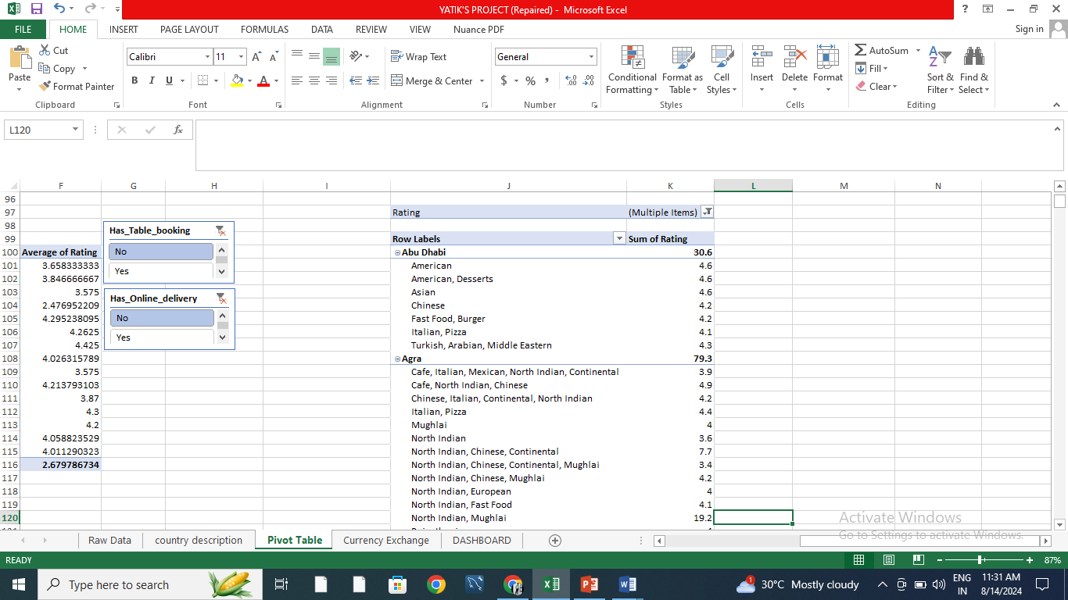

**Q7.** According to our current data, should we go for online delivery and table booking? Does that affect the customer’s ratings?

* Those restaurants which are having online delivery and table booking both are showing an increase in ratings. Therefore, we can say that online delivery and table booking does affects the customer’s ratings.
* **Recommendations: -** Include features of online delivery and table booking for the ease of customer.

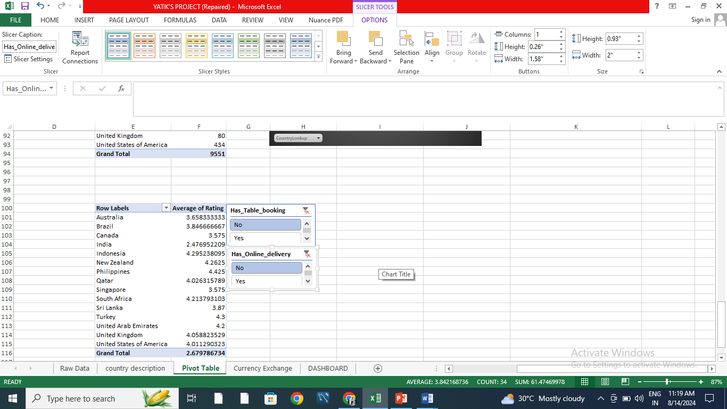

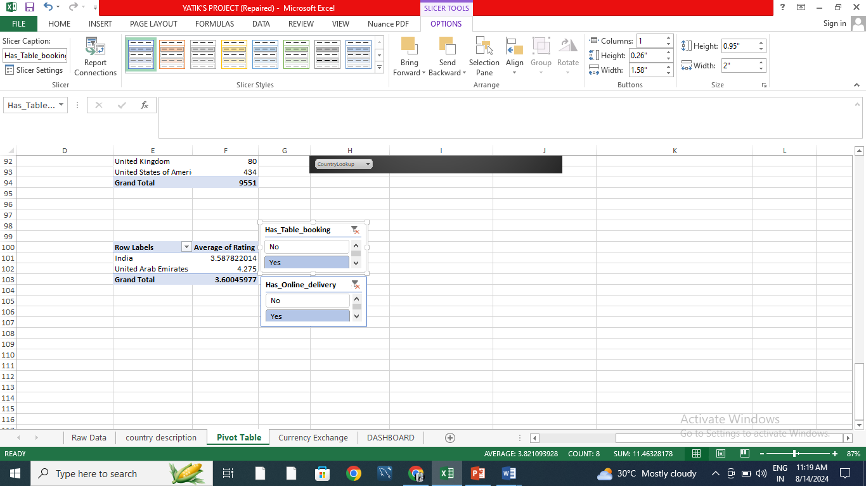

**Q8.** Should the team keep the rate of cuisines higher? Will that affect the feedback? According to our data are the rates of cuisines and ratings, correlated?

**Insights: -** As the linear forecast trend line is moving slightly upward direction and the correlation coefficient is moving towards +1, therefore, we can say that the rates of cuisines and ratings are positively correlated i.e. as one variable increases, the other tends to also increase.

**Recommendation: -** Seeing the insights doesn’t mean we should increase the price of every cuisine in every country to get better ratings. We should also look the country wise scatter plot for the rating and average price, and increase the rate where the country allows to do so

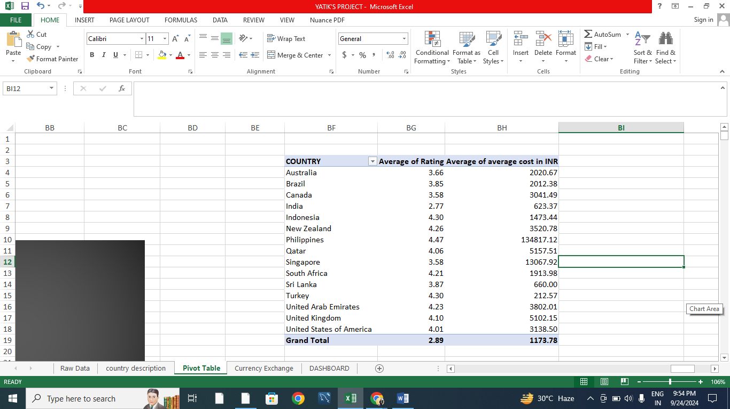

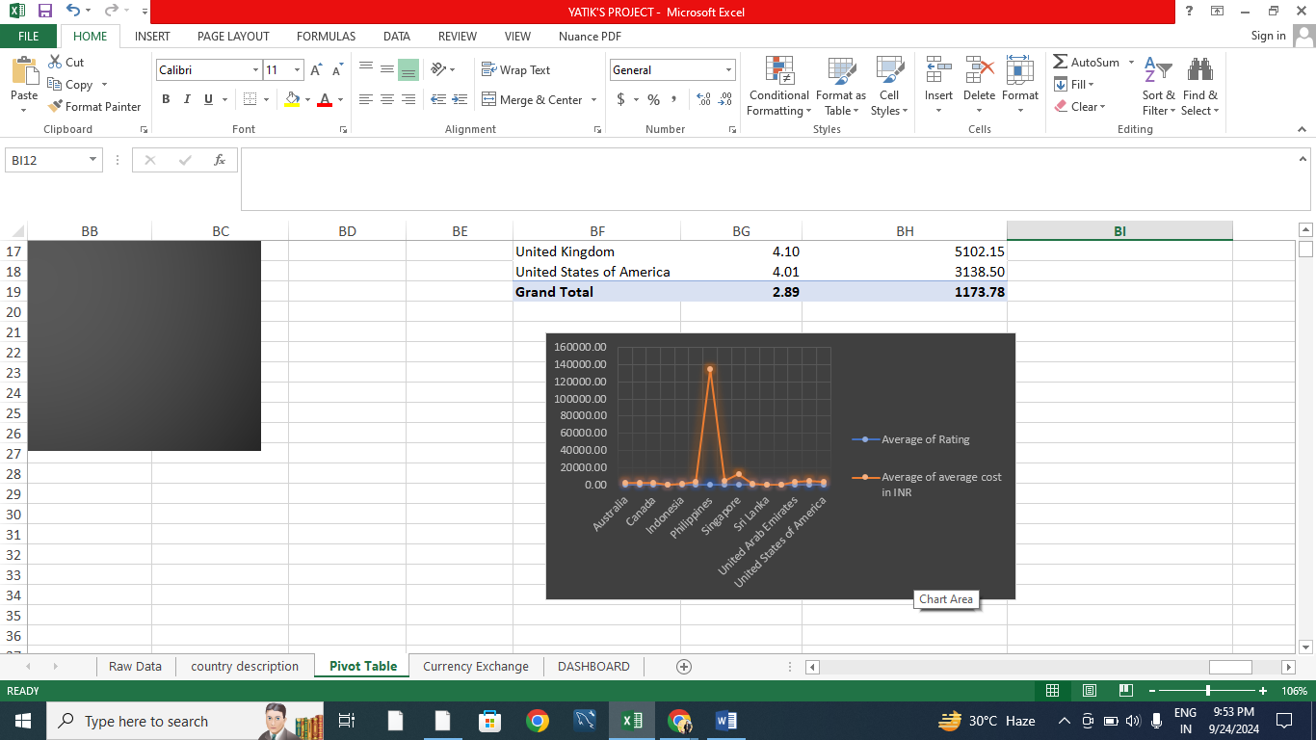

**Q9.** What is the distribution of the number of restaurants of different price ranges in all the countries?

**Approach:** Different countries have different number of restaurants within the different price range. Whereas India have the maximum number of the of the restaurants among all price ranges. States such as the United States, United Kingdom, and South Africa have a more balanced distribution across the different price ranges but with significantly lower totals compared to India. Countries like Indonesia, Sri Lanka, and Qatar, have minimum number of restaurants.

**Insights:**

1. As evident in the Chart, more number of the restaurants i.e. more than 4000 fall under the price range of 1. This indicates that most restaurants offer affordable dining experience.
2. And only few restaurants are in the price range of 4.
3. Number of restaurants gradually reduce as the price range increases. Which may be because of high cost.

**Recommendation:**

1. Opening restaurants in the price range of 1-2 would help us attract a large clientele since we know that majority of the market is between these ranges.
2. Opening restaurants in higher price range like 3-4 would cater to a small audience, offering unique and special dining experience with good quality food may help attract this clientele as they are willing to pay for better experience.



**Q10.** Explain your approach in brief for suggesting countries/cities in order to open new restaurants.

**ANS. Country and City Selection Strategy**:

● **Low Competition**: Select countries and cities based on a strategic analysis of restaurant density. The aim is to enter markets with fewer existing restaurants to minimize direct competition and increase the chances of establishing a strong market presence.

● **Quality of Food**: Focused on cities where the average cost for two is high. This suggests a higher spending capacity among customers, which provides an opportunity to introduce affordable yet high-quality food options. By offering competitive pricing, we can attract cost-conscious customers while maintaining a focus on quality.

● **Ratings :** Approach those cities, restaurants and cuisines those which have higher ratings compare to others.

● **Way of Delivery:** Focused on those countries those have online delivery as well as table bookings because it increase the sales of the restaurants.